**Tucsen Camera evaluation**

Robert K. Buchheim: December 2019

Packaging: The unit is very well protected in its shipping package (exterior cardboard box with plastic corners, interior cardboard box with form-fitting foam for components). In fact, it may be a little “too good”. The Camera body and the power brick are so tightly contained in teh foam package that I had to cut the foam in order to get the components out!

Contents in the package are:

* Camera body (vacuum-sealed with dessicant pack, and a rubber stopper over the optical entrance)
* Power brick (120 VAC input, 12 VDC 8 amp output)
* Power cord
* USB cable (USB 3.0)
* USB drive with Tucsen software

Camera interface is a C-mount thread (female on camera side), so we need a C-mount (male) to 1.25-or 2-inch barrel to mount to telescope focuser drawtube. Wayne is lending one to me. Also purchased from Amazon (Astromania C Mount to 1.25" Video Camera Barrel Adapter Telescope Astrophotography by Astromania Price: $15.99).

Power-on first time: Connect USB cable and power supply, swithc to “ON”: internal lights come on and fan starts up. The fan is a bit noisier than my ST-8, but much larger air flow. Air flow is “in” on the top, and “out” at the back (hence away from the ‘scope).

Using Win-7-Pro PC, the drivers loaded promptly (with no user intervention).

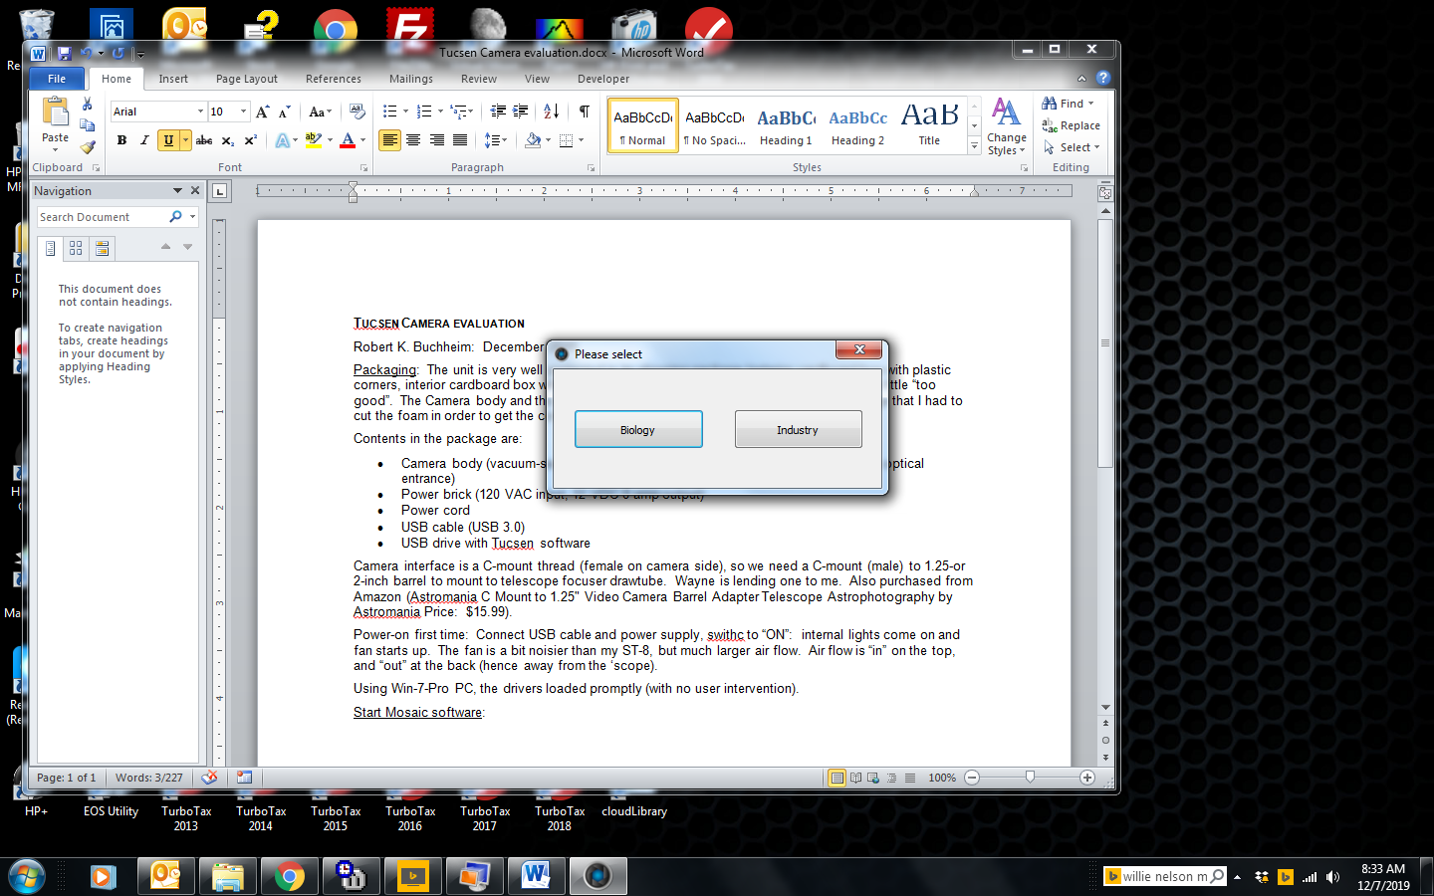Start Mosaic software: At start-up, the software asks:

I’ll try both...

“Industry” selected: Mosaic2.1 throws an error message:

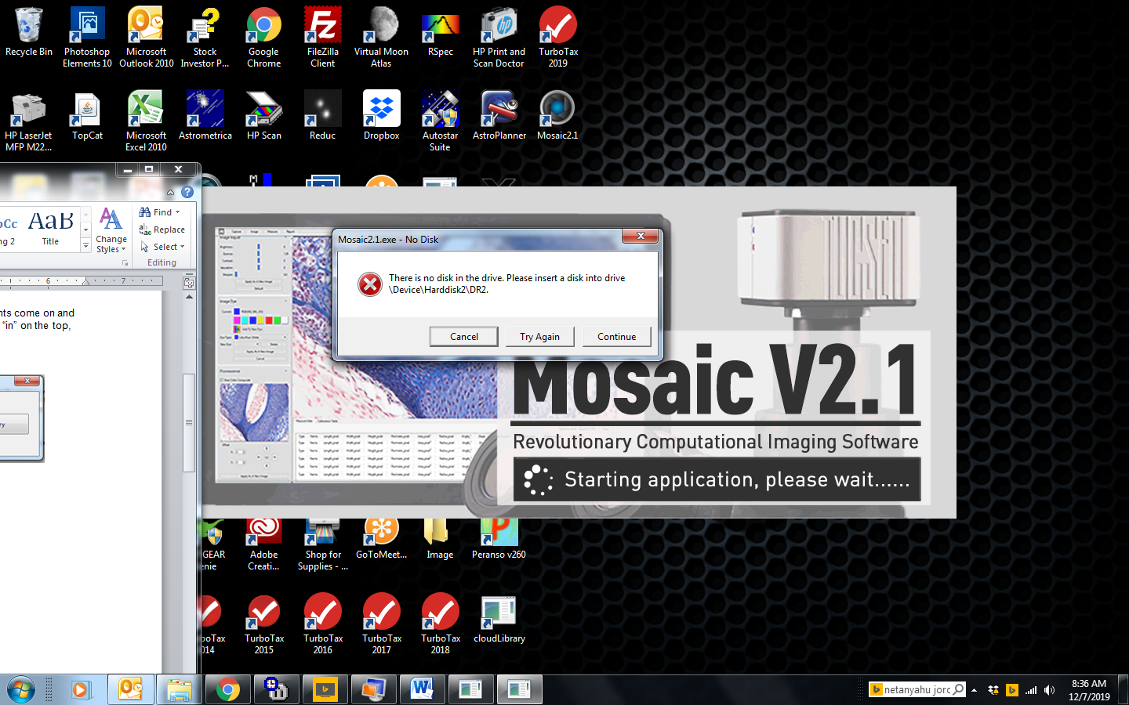

Select “Continue”... after some thinking, the main screen appears:

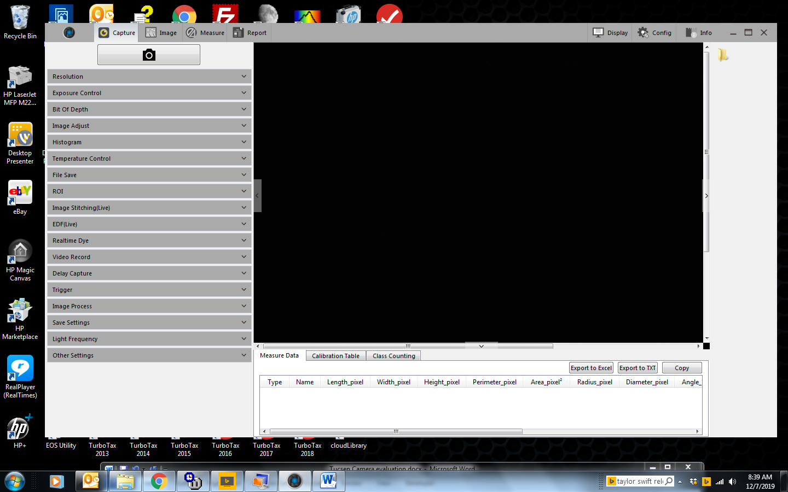

Happily, within the “INFO” menu (far right menu item) there is a user manual.

Also, I’m getting an error message:

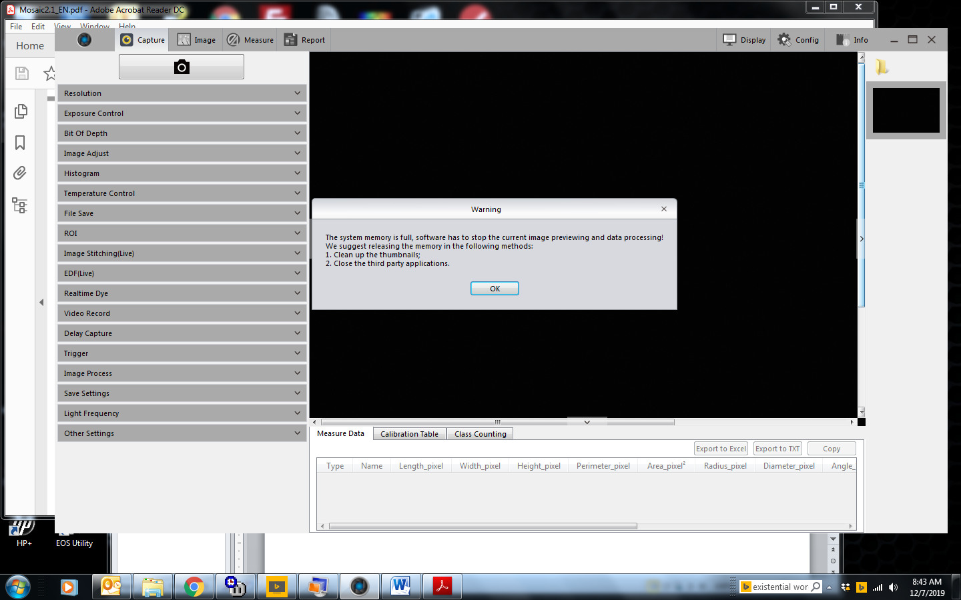

That is probably related to my computer, but we’ll see ... I closed all open applications, and the warnign message disappeared.

A few experiments (before reading the user manual):

The “Temperature Control” allows you to adjust the fan speed (High-Medium-Low) and Cooling (Low- 0°C- Normal). At start-up, the camera defaulted to High speed fan, and Low-temp. It reported temp= -18.31 C. When I reduced the fan to “Medium” speed, the temp rose to about -17C (room ambient was about 73F≈ +23 C).

I set the temp to 0°C and fan to “medium”: the reported temperature fluctuated from about -1.5 to +1.5 C, with occasional excursions as high as 2.2 C and as low as -2C. The readout of reported temp changes roughly every second, and changes surprisingly widely from second to second.

The menu along the left-hand side of the screen offers quite a few configuration options:

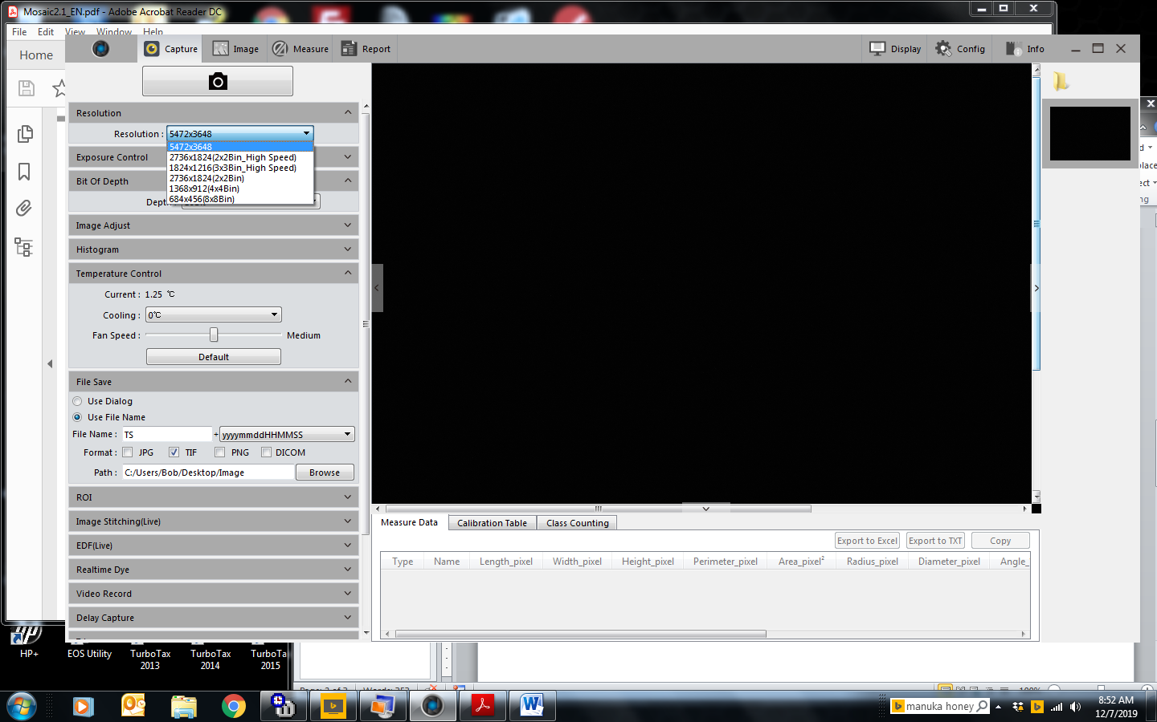

The images are big (full res = 5472 x 3648). The software offers 8-bit or 16-bit output. Alas, of the file-type options, FITS isn’t included.

I tried a 600-sec JPG image (with cap on camera). The image was completed in much less than 600 sec (ctual elapsed time was just a few seconds).

I tried a 600-sec TIF with the same result – image was downloaded in just a few seconds. TIF header reported a 16-bit image, but the exposure duration was not listed.

... OK, time to read the manual.